Whispering Wilds Design Doc

Pros/Fixed
Old Feedback Fixes Implemented:
- UI improvements: auto-scroll in main output, clickable items/NPCs that auto-fill commands, pinned side panels (map, quests, inventory, help), and command history recall (↑/↓).
- Batch actions: numeric repetition added (e.g. “forage 5”).
- Crafting visibility: added recipes command to list craftable items.
- Quest UX: hints for turn-in requirements; quests panel shows progress and ready-to-turn-in status.
- Mini-map: displayed after move/go; separate map panel can be updated with map.
- Tutorial and tips: first-time tutorial, first-time tip system, and help reorganized.
- Bug fixes: caretaker dialogues fixed; help ordering corrected; lore now detects seen creatures; XP system with level progression and XP display added; bandages and consumables usable; drop/use work correctly; mine matters soft-lock fixed; Angler Aid no longer re-offers after completion.
- Combat updates: power strike implemented, and combat UI clarified.
- Hidden areas: descend/dive/climb commands connect to deep mine, lake depths, crystal cave, sunken shrine, and tower top.
- Economy balance: crafted healing potion renamed to “Lesser Potion” (8 HP) to distinguish from shop “Healing Potion” (20 HP); NPC conversation micro-goal counts unique NPCs; resource gathering adds cooldown; armor status shown in inventory/stats.
- Custom quick buttons: players can create custom buttons with labels and commands; buttons stored in local storage with append mode toggle.

- Caretaker say dialogue no longer empty
- Can use 1 instead or as well as say 1
- Foraging, Harvesting, Mining, Fishing now chainable up to 10
Inventory auto updates and has own ui element
- Mine matters quest now able to be completed
- Quests no longer re-offered while not available

Bugs
Notes say that multiple forages may trigger encounters but I've done 5 sets of 10 and had nothing.

up arrow now no longer goes to latest command but instead second last command

took first item after foraging a bunch and got treasure hunter, think i have 3 at most
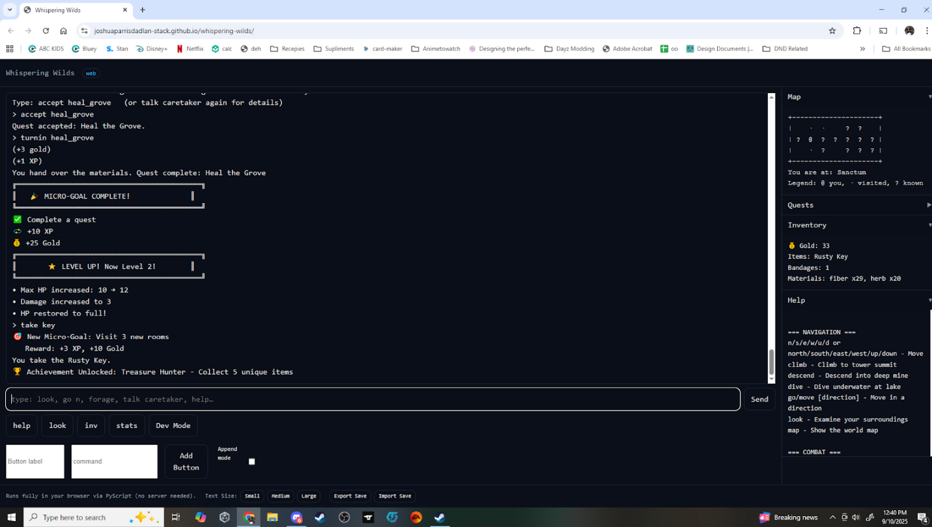

save function didn't seem to return anything and then load said no save found.

Still couldn't get into that row 3 column 5 space. I assume that's where the hermit is. tried moving from both directions and climbing from both directions.

Couldn't find coal, tried mining a bunch of places and ended up with the pickaxe and 80 ore

Couldn't get pearls so i assumed that's what you dive for, do you need the torch? if so that doesnt make much sense as its water with a torch...

Couldn't find crystal shards

Couldn't find anywhere to descend, sunken cellar has no passage down and mineshaft is collapsed

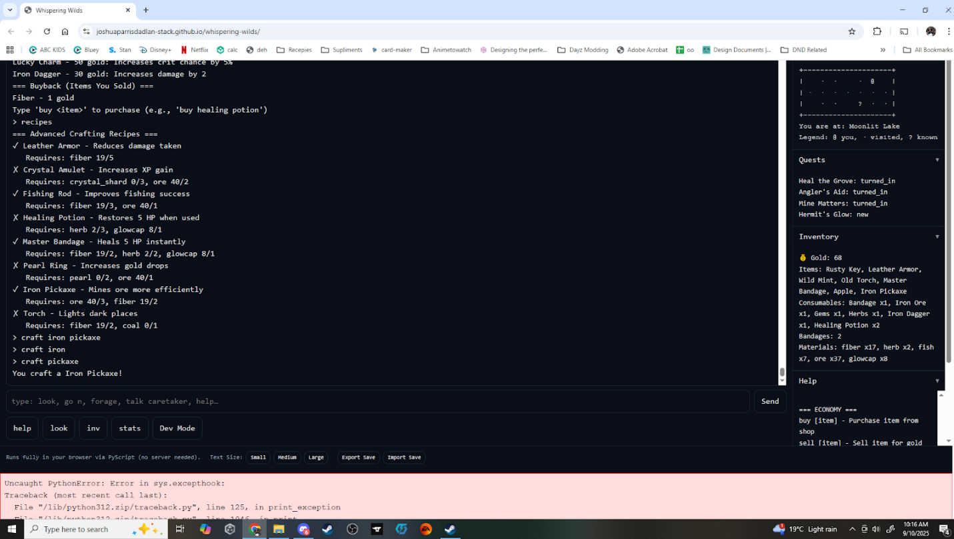
Just got the talk to 2 npc's a second time.

craft iron pickaxe is craft pickaxe

mine matters didnt detect the ore, could still hand in but said 0/2 when i had 42

Craftable healing potion heals 5,
buyable healing potion heals 20,
both same name
both stack

cant buy or sell multiples

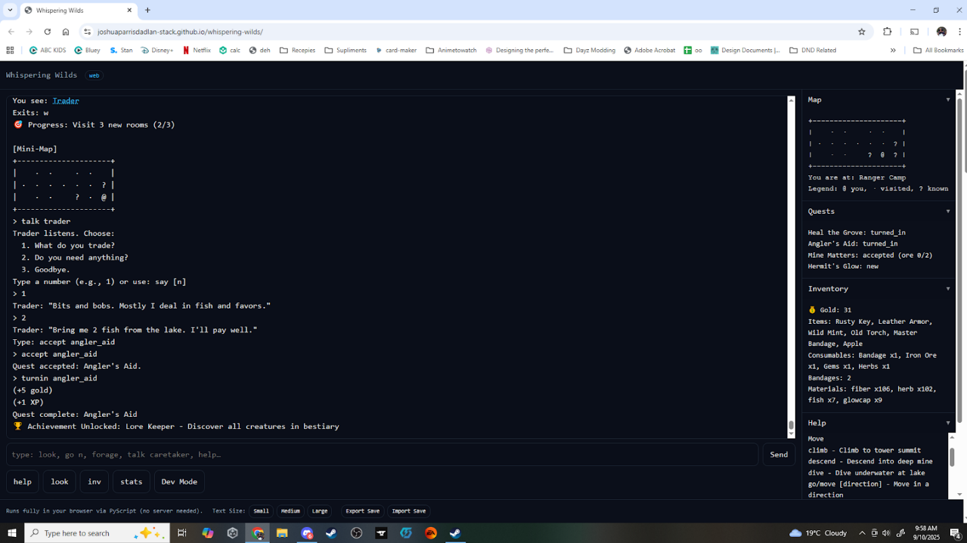
finished angler_aid and got the lorekeeper achievement

Craft no longer prompts you to use the recipe command

In map legend ? = known. Needs to be Unknown

Suggestions
I'm feeling that at some stage people will miss things and will need a way to keep track of what has been done where.

It would be good in my opinion to have a function you can call that will list all possible actions and display them categorized into success, failed and untried for example:

=History Sanctum
Success: Talk, Forage, Hunt, Take
Failed: Climb, Descend
Untried: Fish, Dive, Search, Unlock, Mine, Harvest

this way it's still on the player to try everything but they can keep track of what they have and havent tried, you could even link the command to a book/ jornal they have to buy making it a mid game item

mini map is useful but might be good to have a toggle, a tick box up where the map is saying something like "display map on move"

i'd also love the option to summarize foraging/looting. The performed 10/10 is great for info and some people will like it being listed as 10 lines but if possible it would be nice if there was an option to display it like
Performed 10/10
Found:
5X herb
5X fiber

once i unlocked the power strike i never used attack again, also it seems to have 100% hit rate, the hit rate isnt bad but the power strike needs a cooldown or cost of some kind

would be nice to be able to click the quest (like with items and npcs) also clicking highlighted text replaces text not adds to it. not sure if this is bug or feature but usually i want to add the command not replace it.

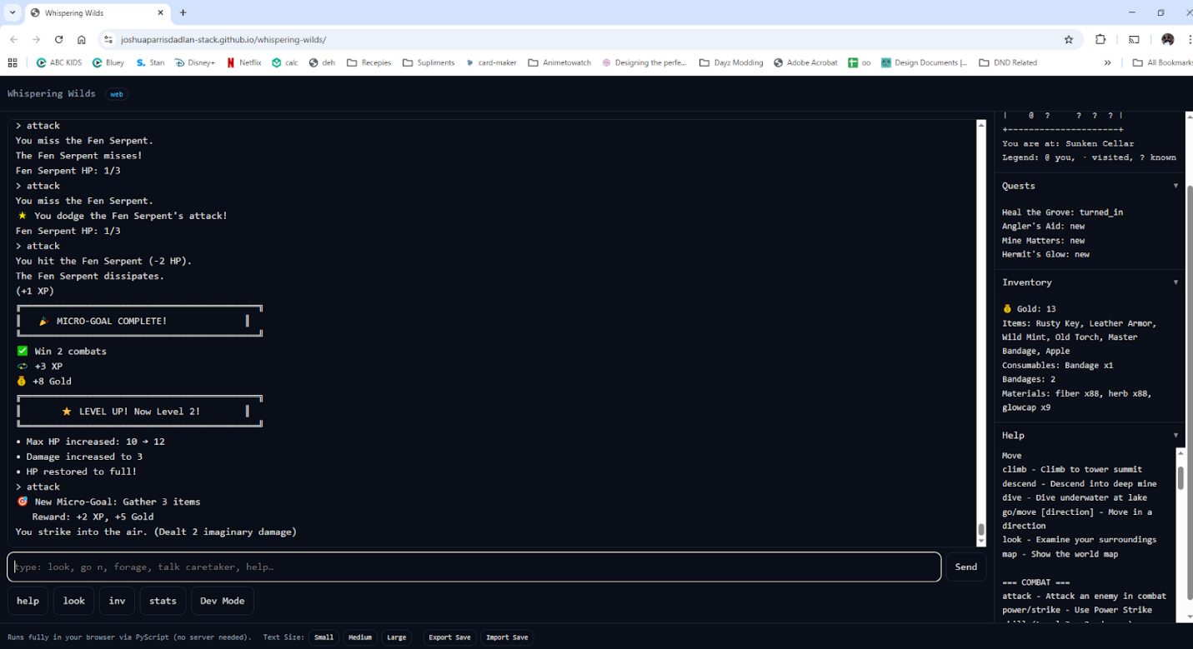
the screenshot above is me getting the micro goal quest, just finished it and got confused. maybe just a me issue but with the reward attached it made me thing it was rewarding me not spelling out a future reward

Not clear if having armor is passive or needs to be equip somehow.

Took me a while to see the difference between potions and master bandages would suggest reducing the healing and the herb cost and making it a bandage that gives 2-3 hp, then combining the potion and the bandage into a master bandage that gives 8hp or something, gives each a clear use and sense of progression rather than feeling like you can farm and ignore one or the other.

Might be good to have the harvest say "nothing to harvest here, x plant grows in x locations" this lets you expand harvestables much more easily.

Summary of Previous Feedback and Corresponding Fixes
What Jayden Liked:
- Engaging gameplay – held his attention for more than 30 minutes.
- Map command – very helpful for navigating.
- Command buttons – quick access buttons made play easier.
Quality-of-Life Suggestions:
- Better scrolling behavior – auto-scroll with bottom text and a dedicated scroll bar instead of an ever-expanding page.
- Clickable commands/items – clicking NPCs or items should auto-fill the appropriate command.
- Pin panels/messages – pin map, quests, inventory, or help into separate columns for easy reference.
- Up-arrow history & batch actions – ability to recall previous commands and batch commands (e.g., “forage 5”).
- Clearer crafting list – show which items can be crafted.
- Map auto-update – show map automatically after movement.
- Custom command buttons – allow users to create their own quick command buttons.

Gameplay Issues:
- Difficulty figuring out how to turn in quests and use bandages.
- Row 3 column 5 inaccessible.
- Caretaker dialogues (say options 2–4) were broken in some cases.
- Help commands were out of order.
- Lore command didn’t detect creatures.
- “xp” command missing; unclear purpose of XP.
- Bandages couldn’t be used even when present.
- Drop/use didn’t work consistently; mine matters quest didn’t detect ore.
- Angler Aid quest re-offered but couldn’t be re-accepted.

Old Feedback Fixes Implemented:
- UI improvements: auto-scroll in main output, clickable items/NPCs that auto-fill commands, pinned side panels (map, quests, inventory, help), and command history recall (↑/↓).
- Batch actions: numeric repetition added (e.g. “forage 5”).
- Crafting visibility: added recipes command to list craftable items.
- Quest UX: hints for turn-in requirements; quests panel shows progress and ready-to-turn-in status.
- Mini-map: displayed after move/go; separate map panel can be updated with map.
- Tutorial and tips: first-time tutorial, first-time tip system, and help reorganized.
- Bug fixes: caretaker dialogues fixed; help ordering corrected; lore now detects seen creatures; XP system with level progression and XP display added; bandages and consumables usable; drop/use work correctly; mine matters soft-lock fixed; Angler Aid no longer re-offers after completion.
- Combat updates: power strike implemented, and combat UI clarified.
- Hidden areas: descend/dive/climb commands connect to deep mine, lake depths, crystal cave, sunken shrine, and tower top.
- Economy balance: crafted healing potion renamed to “Lesser Potion” (8 HP) to distinguish from shop “Healing Potion” (20 HP); NPC conversation micro-goal counts unique NPCs; resource gathering adds cooldown; armor status shown in inventory/stats.
- Custom quick buttons: players can create custom buttons with labels and commands; buttons stored in local storage with append mode toggle.

